I am autistic.  I am exempt from wearing a  face mask. | 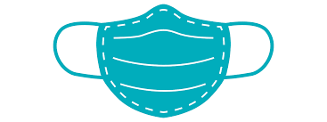    Wearing a mask can cause sensory difficulties that may lead to distress.
Dwi’n awtistig.  Dwi wedi fy eithrio o wisgo  mwgwd wyneb. | Gall gwisgo mwgwd achosi anawsterau synhwyraidd a allai arwain at drallod.
I am autistic.  I am exempt from wearing a  face mask. | Wearing a mask can cause sensory difficulties that may lead to distress.
I am autistic.  I am exempt from wearing a  face mask. | Wearing a mask can cause sensory difficulties that may lead to distress.
I am autistic.  I am exempt from wearing a  face mask. | Wearing a mask can cause sensory difficulties that may lead to distress.

