How to use your ‘Orange Wallet’ on the bus

What is ‘The Orange Wallet’?
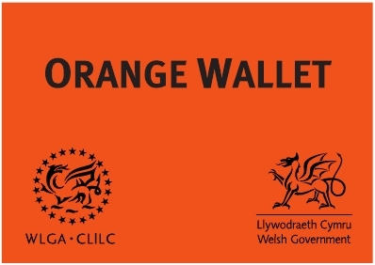
The Orange Wallet is instantly recognised by bus companies. If you show a member of staff your wallet they will know that you have difficulty communicating and need some help.

How is it used?

The Orange Wallet contains plastic pockets where you can insert words and pictures. You may show these to staff to help you to communicate your needs.

How to create words and pictures
Some words and pictures have been created which you may choose to use. You can also create your own words and pictures which should be 90mm by 60mm.

In an emergency

You are advised to have contact details of friends or family in your wallet to contact in an emergency. If you are distressed please show a member of staff your wallet to indicate that you need help.

Any other benefits?


The Orange Wallet does not provide any financial benefit or priority over other passengers. Its purpose is to help you to communicate your needs.

