Advice Sheet for Patients
This sheet offers advice to autistic patients on accessing health care, with tips for what to do before, during and after the appointment with the GP.
Appointments might take place in person, over the telephone, email or on a virtual call. Following the Covid-19 pandemic, there may be changes in the steps to access health care. For example, you will need to call the surgery to book an appointment before you attend in person. There might be a different door to enter and exit the building, which is different to how things used to be. You may not be able to turn up early and sit in the waiting room anymore before your appointment. Make sure that you find out what the rules are in your local surgery by checking their website or calling the surgery to ask.

Before

Medical Passport
Do you have a medical passport? National Autistic Society (NAS) have created a medical passport which you may find helpful. Complete the passport and send it to your surgery before your appointment.
The passport can be accessed by following this link (it is currently only available in English): https://www.autism.org.uk/advice-and-guidance/topics/physical-health/my-health-passport. Remember to also take a copy of your medial passport with you to your appointment.
Accessing the Service
When you call the surgery to book your appointment with the GP or nurse, make sure that you ask what you need to do to access the service. Is your appointment taking place in person? If so, what will you need to do when you arrive, will you need to bring a mask with you? If the appointment is taking place virtually, what platform will be used (e.g. Zoom, Skype, MS Teams etc.)?
eConsult
If you do not like using the telephone, you may be able to book your appointment online via eConsult: https://patients.econsult.health/. If you do not know what is wrong with you, there is a feature on this platform which allows you to click the part of the body where you are experiencing discomfort or pain. It looks like this:
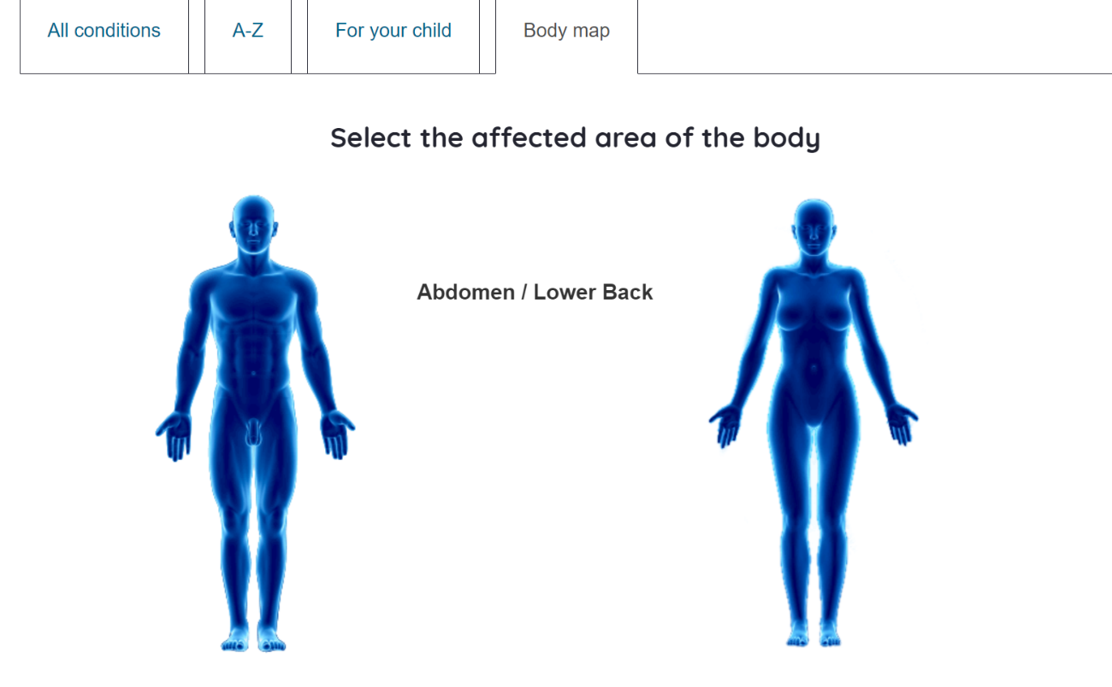
However, not all surgeries use this platform, and you may need to use the telephone to book your appointment if your surgery is not on the list.
Preparation
Before you see your GP or nurse, write down a list of things you want to discuss in the appointment in case you forget. Write down any long-term illnesses or allergies that you have (e.g., nut allergy) and also write down the specific reasons for booking an appointment this time (e.g. stomach pain).
Ask if you can bring someone with you to your appointment (e.g. a parent/ carer). You may not be allowed into the surgery until it is time for your appointment, so do not arrive early like you usually would before Covid-19.

During

Medical Passport
Make sure to show your GP or nurse your medical passport at the beginning of the appointment.
Communication
Make sure you understand what the GP or nurse tells you. If you do not understand, ask for clarification, or for the information to be repeated.
It may be helpful to ask your GP or nurse to write down what they say in case you forget. This way, you can read it again when you are back home, or show someone that might need to know what is wrong with you (e.g. a pharmacist or a parent/carer).
Next Steps
Before you leave your appointment, make sure you know what happens next.
- Do you need to go to the pharmacy to pick up your prescribed medication?
- Do you need to be referred to a different surgery or hospital? If so, make sure that your GP, nurse or surgery staff help you to book the next appointment and give you information on how to get there. Make sure you know why you are being referred to another appointment, e.g. a scan.

After

Prescriptions
If you have been given a prescription, make sure that you go to the pharmacy after your appointment to pick up your medication. Make sure that you ask the pharmacist how to take the medication. Do you need to take the medication with food? How many times a day do you need to take the medication? A day by day pill box/ dispenser may be helpful.

If you have any problems with the medication, or you do not feel any better after taking it, you can go back to the pharmacy and speak to a pharmacist. The medication should make you feel better, not worse.
If you do not want to speak to the pharmacist, you can go back to your GP or nurse, but you will need to call the surgery before turning up. Make sure you book another appointment with the GP or nurse if you do not feel any better.

